2024

Vipul Dessai

[Awesome Compony]

2/24/2024

DSA – Linked Lists

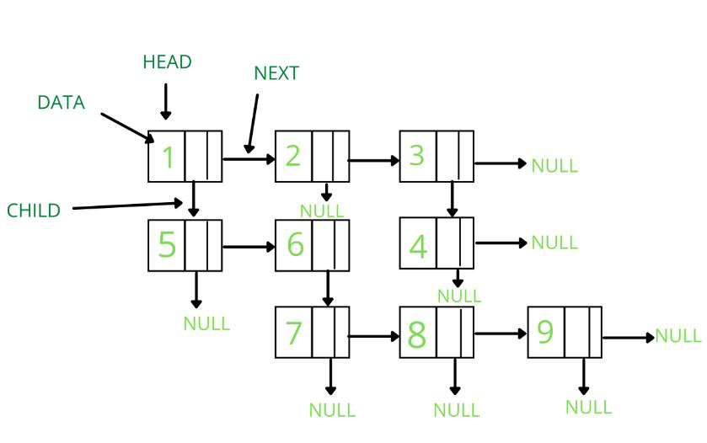

Contents

Merge in between linked lists 2

Intuition 2

Complexity 2

Solution 2

# [Merge in between linked lists](https://leetcode.com/problems/merge-in-between-linked-lists/description/)

## Intuition

Use counter to find c == a and c == b + 1 and later use (b+1).next

Avoid the memory leaks by pointing list2 head to to its tail which can happen if counter counts wrong indices

## Complexity

TC – O(N)

SC – O(1)

## [Solution](https://leetcode.com/problems/merge-in-between-linked-lists/solutions/4902307/simple-counter-based-solution-explaination/?envType=daily-question&envId=2024-03-20)